Sens-AI-tional Project
Predicting AI Efficiency and Business Impact in Organisations Based on Adoption Rate
ENGE707 Assessment 1: Phase 1: Mid-Project Scoping Report

Suemon Kwok: 14883335
Quentin Masoe: 23191960
Avathanshu Bhat: 23227963

Department of Engineering, Computer and Mathematical Sciences
Auckland University of Technology
ENGE707: Data Engineering and AI
[Course Lecturer's Name]
[Due date]

How to use this draft (delete this box before submission)
This is a shared working draft, not a finished submission. Every result, figure, and table below is pulled directly from Ai_adoption_final_fixed.ipynb, so it should not be edited unless the notebook itself changes. Sections marked in orange, like [TEAM TO ADD: ...], are the parts the rubric marks that code alone cannot answer — motivation, licence details, and written justification. Please write directly into this document, track changes if useful, and remove this box and all orange notes before the final export. Reference list entries for the lecture slides still need the presenting lecturer's name confirmed against Canvas.

1. Introduction

1.1 Problem Background and Motivation
Artificial intelligence (AI) adoption has moved from an experimental capability to a mainstream operational concern for organisations across most industries. Companies now vary widely in how far they have progressed along this adoption journey, ranging from no formal use of AI, through pilot projects, to fully scaled deployment across business functions. Understanding what distinguishes organisations at different adoption stages, and how adoption relates to measurable business outcomes such as productivity and revenue growth, is therefore a practically useful analytical problem.
[TEAM TO ADD: 2–3 sentences on the specific motivation for this project, citing at least one external source on AI adoption trends (e.g., an industry report, Stats NZ, or an academic article), and 1–2 sentences naming the stakeholders who would use this analysis (e.g., business leaders, AI strategy consultants, policymakers) and why it is practically relevant to them.]

1.2 Aim and Scope of Phase 1
This report documents Phase 1 of a two-phase group project for ENGE707. Phase 1 is limited to the data engineering foundation of the project: problem and dataset definition, data acquisition and inspection, data cleansing and transformation, and exploratory data analysis (EDA). Feature engineering beyond a single derived variable, machine learning model development, model evaluation, and formal statistical hypothesis testing beyond the two illustrative tests reported in Section 5.8 are scoped for Phase 2 of the project.

2. Dataset Description

2.1 Source, Access, and Licence
[TEAM TO ADD: The exact dataset URL (e.g., the Kaggle listing page), the date it was downloaded, and the licence or terms of use it is published under. State this in one short paragraph in third person, e.g., 'The dataset was accessed on [date] from [source], and is distributed under [licence].' Also confirm the date lecturer approval was obtained.]

2.2 Structure and Variables
The primary dataset, ai_company_adoption.csv, contains 150,000 records and 43 features. Each record represents one quarterly survey response from one of 10,000 companies, covering approximately 16 quarters between 2023 and 2026. The features fall into three broad groups: firmographic variables describing each company (country, region, industry, company size, number of employees, annual revenue, and company age); AI-adoption variables describing the intensity and nature of AI use (adoption rate, adoption stage, maturity score, training hours, budget percentage, primary AI tool, and use case); and outcome variables describing the effects associated with AI use (productivity change, revenue growth, cost reduction, employee satisfaction, and jobs displaced or created).
Two smaller files, ai_industry_summary.csv and country_ai_index.csv, are treated as optional lookup or reference tables in the current notebook and have not been merged into the main analysis. The primary outcome of interest is ai_adoption_stage, a four-level categorical variable (none, pilot, partial, full). A derived binary target, high_adoption, was engineered to flag records where a company had reached the partial or full stage, giving a simpler two-class framing alongside the original four-level variable.

3. Data Acquisition, Inspection, and Documentation

3.1 Loading and Structure Verification
The dataset was loaded in Python using pandas, following the same extract-transform-load structure introduced in the Week 2–3 laboratory exercise on cleaning real-world data (see Section 8; Siddique, 2026a). The raw dataset was confirmed to contain 150,000 rows and 43 columns, matching the documented structure. Of the 43 columns, 15 are stored as 64-bit floating-point numbers, 14 as 64-bit integers, one as a plain string identifier (company_id), and 13 as categorical text fields (for example country, industry, company_size, and ai_adoption_stage). Converting the free-text categorical columns to pandas' category dtype at the loading stage is the data-typing equivalent of the header-naming step used for the arrhythmia dataset in the Week 2–3 laboratory, and reduces memory use for the repeated string values in these columns.

3.2 Data Quality Inspection
A systematic inspection was carried out before any cleaning was applied, checking for missing values, duplicate records, and implausible value ranges. No missing values were found in any of the 43 raw columns, and no fully duplicate rows or duplicate response_id values were present. Table 1 summarises the minimum and maximum values for four representative numeric columns, and the distribution of records across the four adoption-stage categories.

Table 1
Value Ranges for Key Numeric Variables in the Raw Data
Variable | Minimum | Maximum
num_employees | 10 | 19,970
annual_revenue_usd_millions | 1.01 | 9,996.73
ai_adoption_rate (%) | 0.0 | 100.0
ai_maturity_score | 0.000 | 0.904

Table 2
Company-Quarters per AI Adoption Stage (Raw Data)
Adoption stage | Records | Share of total
Partial | 78,800 | 52.5%
Pilot | 64,317 | 42.9%
None | 5,198 | 3.5%
Full | 1,685 | 1.1%

3.3 Logical Consistency Checks
Beyond range checks, records were reviewed for logically inconsistent combinations, mirroring the age/height/weight consistency check used in the Week 2–3 laboratory. Specifically, every record was checked for cases where years_using_ai exceeded company_age, which would be impossible. No such records were found (0 of 150,000). A second check recomputed AI investment per employee from its component columns and compared it against the reported value; 139,098 of 150,000 rows (92.7%) differed from the reported figure by more than $1. This is treated as evidence of independent rounding or estimation in the original survey responses rather than as an invalid record, since the discrepancy is small relative to the value of the variable and does not indicate a logically impossible combination.

3.4 Assumptions
Two assumptions frame the Phase 1 analysis. First, ai_company_adoption.csv is treated as the sole analysis dataset for Phase 1, with the two auxiliary files retained only as optional lookup tables for a possible later phase. Second, a record is treated as logically invalid only where a combination of values would be impossible in reality (for example, more years using AI than the company has existed, or non-positive employees or revenue); values that are merely unusual, such as a small or very large company, are treated as legitimate variation rather than errors and are addressed separately as potential outliers in Section 4.2.
[TEAM TO ADD: Confirm these two assumptions match the group's final agreed framing, and add any additional assumption the group discussed but is not yet captured above.]

4. Data Cleansing and Transformation

4.1 Cleaning Function Overview
All cleaning was implemented in a single clean_data() function applied to a deep copy of the raw data, so that df_original remains untouched and every transformation is reproducible from the raw file. The function performs five steps: (a) removal of any logically invalid records, following the criteria in Section 3.4; (b) engineering of a derived feature, revenue_per_employee (annual revenue in USD divided by employee count), as the equivalent of the body mass index feature used in the Week 2–3 laboratory; (c) a defensive median-fill step for numeric columns; (d) removal of the uninformative response_id identifier column; and (e) de-duplication, followed by construction of the binary high_adoption target.
Applying this function to the 150,000-row raw dataset removed zero records (no logically invalid rows were found, consistent with Section 3.3) and produced a cleaned dataset of 150,000 rows and 44 columns, one column larger than the raw data due to the addition of revenue_per_employee. Because the raw data contained no missing values (Section 3.2), the median-fill step in clean_data() did not alter any values in this run; it is retained in the function as a defensive safeguard so that the pipeline would still behave correctly if a future data refresh introduced missing values.

4.2 Outlier Investigation and Decision
Figure 1
Boxplot of AI Investment per Employee, Showing Right Skew
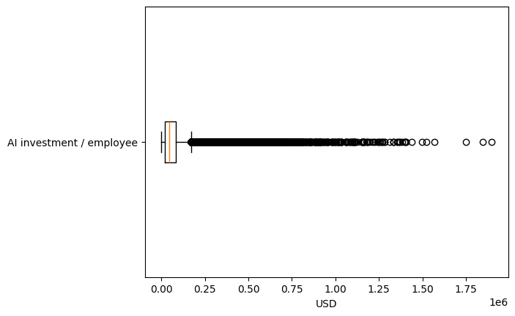
Three heavily right-skewed numeric columns — annual revenue, employee count, and AI investment per employee — were screened for outliers using the interquartile range (IQR) rule. Combined across these three columns, 37,394 of 150,000 records (24.9%) were flagged by at least one IQR fence. AI investment per employee was checked separately using a z-score threshold, with 3,063 records (2.0%) showing a standardised score beyond ±3.
These flagged values were retained in the main cleaned dataset (df_etl_clean) rather than removed or capped. This decision reflects the fact that the flagged records are large or small companies at the natural extremes of the size distribution — for example, an enterprise with tens of thousands of employees, or a small startup with very high AI investment per employee — rather than data-entry errors. Because company size and AI investment intensity are themselves meaningful predictors of adoption behaviour, removing these records would discard genuine variation that Phase 2 modelling may need. To check how sensitive the descriptive results are to this choice, a separate sensitivity-only copy of the data was created with the same three columns capped at their IQR fences; this copy is not used elsewhere in the pipeline.
Figure 2
Sensitivity Check: Revenue, Employees, and AI Investment per Employee After IQR Capping
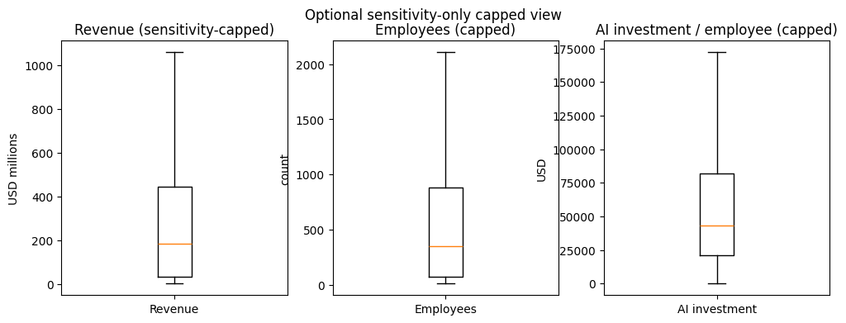
[TEAM TO ADD: 2–3 sentences comparing the capped view above with the uncapped Figure 2, stating in the group's own words whether capping changed the overall shape enough to reconsider the outlier decision.]

4.3 Reproducibility: ETL and ELT Demonstration
Both an ETL (extract, transform, load) and an ELT (extract, load, transform) pattern were demonstrated using SQLite, following the same structure as the Week 2–3 laboratory. In the ETL pattern, the already-cleaned dataset was written directly to a clean table in etl.db. In the ELT pattern, the raw data was first loaded into a raw table in elt.db, with cleaning applied afterwards to populate a second clean table in the same database. Both approaches produced an identical cleaned shape of 150,000 rows by 44 columns, confirming that the cleaning logic is consistent regardless of where in the pipeline it is applied.

5. Exploratory Data Analysis and Visualisation

5.1 Descriptive Statistics and Skewness
Table 2 reports descriptive statistics for four key numeric variables in the cleaned dataset. Adoption rate and maturity score are close to symmetric (skewness of 0.06 and 0.18 respectively), employee satisfaction score is close to symmetric (0.01), and productivity change is moderately right-skewed (0.30), meaning a minority of companies report unusually large productivity gains. Overall, 53.7% of company-quarters fall into the high_adoption group (partial or full adoption stage), against 46.3% in the low/no-adoption group, indicating the binary target is reasonably balanced.
Table 3
Descriptive Statistics for Key Numeric Variables (n = 150,000)
Variable | Mean | SD | Min | Max | Skewness
AI adoption rate (%) | 36.41 | 14.54 | 0.00 | 100.00 | 0.06
AI maturity score | 0.34 | 0.13 | 0.00 | 0.90 | 0.18
Employee satisfaction score | 5.60 | 0.81 | 2.10 | 9.20 | 0.01
Productivity change (%) | 9.27 | 5.64 | 0.00 | 34.36 | 0.30

5.2 Distributions Before and After Cleaning
Figure 3
Distribution of AI Adoption Rate in the Cleaned Data
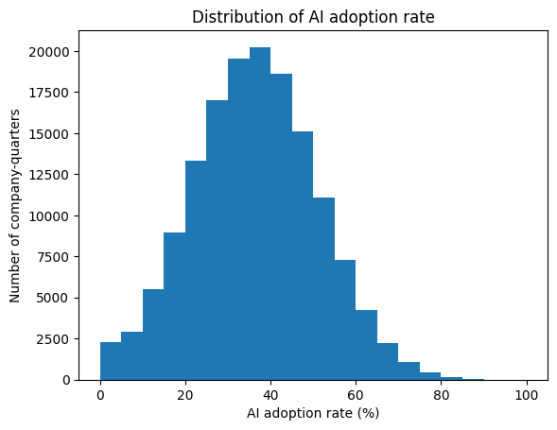
Figure 4
Distribution of Revenue per Employee in the Cleaned Data
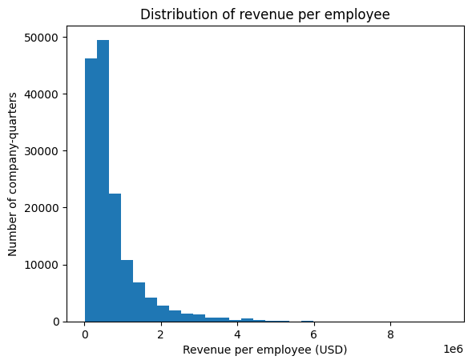
Because no records were removed during cleaning (Section 4.1), the raw and cleaned ranges are identical for every numeric column checked: employee count (10 to 19,970), annual revenue (USD 1.01 million to USD 9,996.73 million), and adoption rate (0% to 100%) are unchanged between df_original and df_etl_clean. The histograms above therefore illustrate the shape of the cleaned distributions rather than a before/after contrast in range.

5.3 Missing-Value Check
Consistent with the inspection in Section 3.2, no missing values were found in any column of the raw data, so no missing-value plot was generated by the notebook; a missingness bar chart is produced automatically only when at least one column has a non-zero missing rate. This absence of missing data is notable for a dataset of this size and is discussed further in Section 6.

5.4 Group Comparisons and Correlation Structure
Figure 5
High-Adoption Rate by Company Size
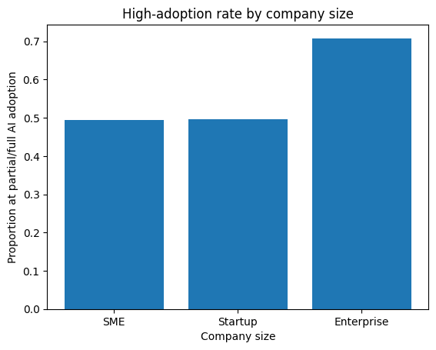
The proportion of company-quarters at partial or full adoption rises with company size: 49.4% for SMEs, 49.6% for startups, and 70.8% for enterprises. This gap is explored further with a formal hypothesis test in Section 5.8.

Figure 6
Correlation Heatmap for Seven Numeric AI-Adoption and Outcome Variables
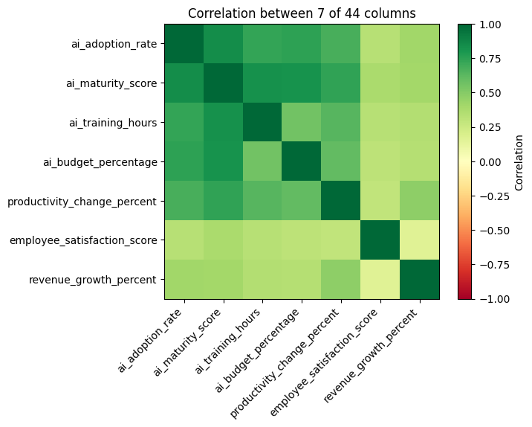
Among the seven numeric variables compared, the strongest pairwise correlation is between AI adoption rate and AI maturity score (r = 0.84), which is expected since both measure related aspects of how far a company has progressed with AI. Adoption rate and maturity score are also strongly associated with AI training hours (r = 0.73 and 0.82) and AI budget percentage (r = 0.74 and 0.82). Productivity change correlates moderately with maturity score (r = 0.74), while employee satisfaction shows the weakest relationships with the AI-adoption variables overall (r between 0.29 and 0.38).

5.5 Adoption-Stage Profile
Figure 7
Standardised Profile of Key Metrics Across the Four Adoption Stages
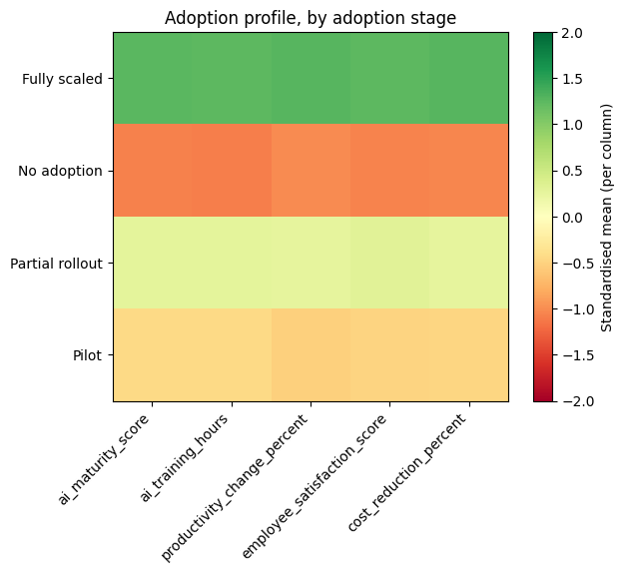
Table 3 shows the mean profile for five outcome-related variables across the four adoption stages. Every metric increases monotonically from the none stage to the full stage, most sharply for AI training hours (7.66 to 52.75 hours) and productivity change (2.39% to 19.79%).

Table 4
Mean Profile of Selected Metrics by AI Adoption Stage
Adoption stage | Maturity score | Training hours | Productivity change (%) | Satisfaction score | Cost reduction (%)
None | 0.12 | 7.66 | 2.39 | 5.09 | 2.19
Pilot | 0.26 | 19.85 | 6.17 | 5.38 | 3.76
Partial | 0.42 | 33.95 | 12.03 | 5.80 | 5.77
Full | 0.65 | 52.75 | 19.79 | 6.29 | 8.59

5.6 Relationships Between Variables
With 150,000 rows, scatter and pair plots of the full dataset are too dense to interpret visually, so a random sample of 3,000 rows (random_state = 42 for reproducibility) was drawn for these visuals only; all summary statistics and hypothesis tests elsewhere in this report use the full cleaned dataset.

Figure 8
AI Maturity Score vs Productivity Change, Coloured by Adoption Group (n = 3,000 Sample)
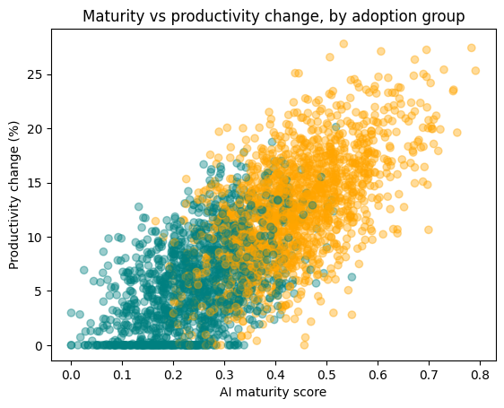

Figure 9
Pairwise Relationships Among Four Adoption and Outcome Variables (n = 3,000 Sample)
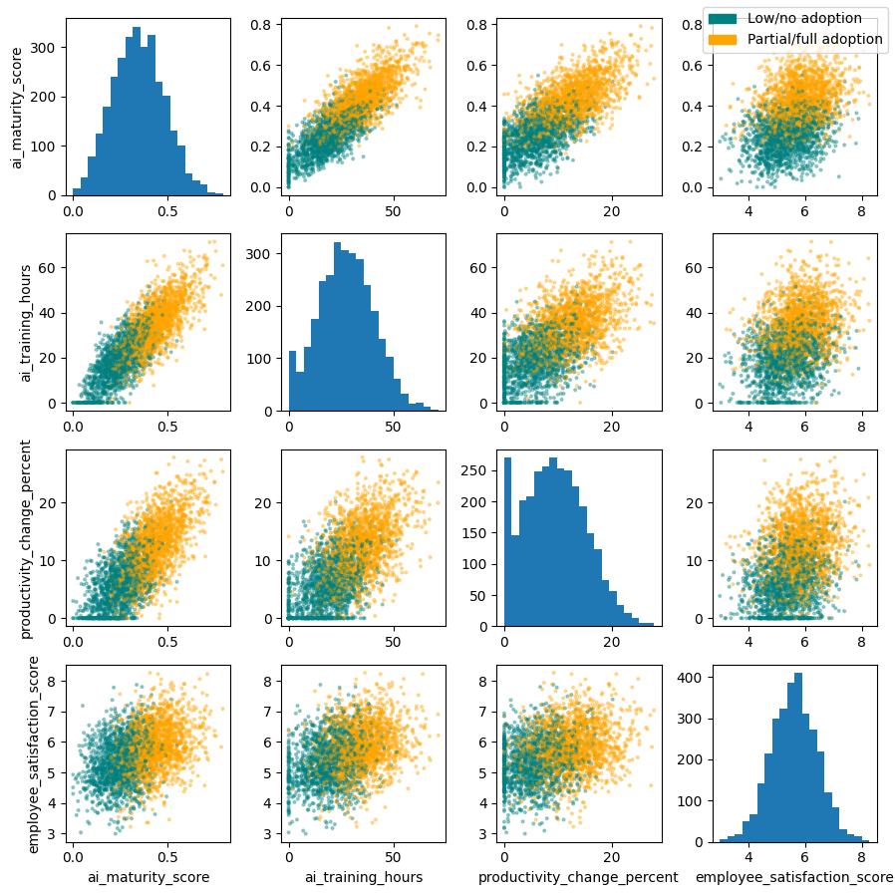
Note. Diagonal panels show univariate histograms; off-diagonal panels show pairwise scatterplots, coloured by high_adoption group (teal = low/no adoption, orange = partial/full adoption).

5.7 Key Insights
[TEAM TO ADD: Write 4–6 sentences in the group's own words summarising what these results say about the structure, quality, and usefulness of the dataset for Phase 2 modelling. A possible starting point, to be rewritten rather than copied: the dataset is clean and complete (no missing values, no duplicates, no logically invalid records), it is class-balanced enough for binary classification, and its numeric predictors are correlated strongly enough with the adoption-related variables to suggest they will carry predictive signal in Phase 2, while the weak relationship with employee satisfaction suggests that variable may need separate treatment.]

5.8 Statistical Hypothesis Testing
Two illustrative hypothesis tests were run to check group differences already suggested by the descriptive results above, following the same pairing of a two-sample t-test and a chi-square test of independence used in the Week 2–3 laboratory.
Table 5
Independent-Samples t-Test: AI Maturity Score by High-Adoption Group
Group | Mean maturity score | Test statistic | p
High adoption (partial/full) | 0.429 | t = 356.96 | < .001
Low/no adoption (pilot/none) | 0.248 | — | —

The mean AI maturity score is substantially higher for the high-adoption group than for the low/no-adoption group, and this difference is statistically significant, t = 356.96, p < .001. The null hypothesis of equal mean maturity scores between the two groups is rejected.
Table 6
Chi-Square Test of Independence: Company Size by High-Adoption Group
Statistic | Value
χ² | 4320.71
Degrees of freedom | 2
p | < .001

A cross-tabulation of company size against the high_adoption flag shows enterprises reaching high adoption far more often (20,843 of 29,448, 70.8%) than SMEs (31,527 of 63,867, 49.4%) or startups (28,115 of 56,685, 49.6%), consistent with Figure 3. This association is statistically significant, χ²(2, N = 150,000) = 4320.71, p < .001, so the null hypothesis that company size and high adoption are independent is rejected.

6. Discussion and Dataset Suitability for Phase 2
Taken together, the inspection, cleaning, and EDA results indicate the dataset is well suited to the Phase 2 modelling task of predicting AI adoption stage and linking it to business outcomes. The absence of missing values and duplicate records across 150,000 rows means Phase 2 can proceed directly to feature engineering without a substantial cleaning burden. The binary target is close to balanced (53.7% / 46.3%), which reduces the risk of a model that trivially predicts the majority class. The strong correlations between adoption-related predictors (r up to 0.84) suggest these features will carry predictive signal, though their mutual correlation also means Phase 2 should consider multicollinearity when selecting a feature set for the Learning Classifier System and comparison models.
[TEAM TO ADD: Add 2–3 sentences reflecting on any limitations the group has identified so far (e.g., the unusually clean/complete nature of the raw data, the untested assumption that the auxiliary lookup tables are not needed, or any ethical/bias considerations relevant to AI-adoption data across countries and industries).]

7. Deliverables Status
Table 4 summarises the status of each Phase 1 deliverable against the assessment brief at the time of writing.

Table 7
Phase 1 Deliverables Checklist
Deliverable | Status
Python/Jupyter notebook, executed end to end | Complete — 21 code cells, no errors
Cleaned dataset or reproduction instructions | [TEAM TO ADD: export df_etl_clean to CSV, or confirm reproduction steps]
Data pipeline diagram | [TEAM TO ADD: see Appendix A]
Progress report (2,500–3,000 words) | In progress — this document
Turnitin similarity check (< 20%) | [TEAM TO ADD: run before submission]

8. Conclusion
This report has documented the data engineering foundation of the AI adoption prediction project: dataset selection and approval, acquisition and inspection, cleansing and transformation, and exploratory data analysis. The cleaned dataset of 150,000 records across 44 columns contains no missing values or duplicates, a close-to-balanced target variable, and clear relationships between AI-adoption intensity, company size, and business outcomes, providing a sound basis for the feature engineering and model development planned for Phase 2.

References
Siddique, A. (2026a). Cleaning real data before you trust it: Week 2 and 3 [Lecture slides]. Auckland University of Technology. Canvas.
Siddique, A. (2026b). Data engineering and AI: Course introduction [Lecture slides]. Auckland University of Technology. Canvas.
[TEAM TO ADD] (2026). [Dataset title] [Data set]. [Source, e.g., Kaggle]. [URL]
[TEAM TO ADD: Add a reference for any other lecture slide sets cited in the final text (e.g., Week 1 foundations, Week 4 machine learning techniques), and any external source used in Section 1.1, all in APA 7th edition format, alphabetised by author surname.]

Appendix A: Data Pipeline Diagram
[TEAM TO ADD: Insert the data pipeline diagram here (e.g., raw CSV → load/type → inspect → clean_data() → feature engineering → cleaned dataset → EDA/visualisation → [Phase 2] model input). A simple flowchart made in draw.io, PowerPoint, or Python (e.g., Graphviz) is sufficient.]

Appendix B: Team Contribution Statement
[TEAM TO ADD: State each member's contribution to Phase 1 (e.g., dataset sourcing, notebook development, report sections written), confirming equitable contribution as required by the assessment terms and conditions.]

